# Книжка.
Systemd для администраторов.pdf

# 20200917
# Here is a way how to find systemd service.
#
root@ds-net-ilb01:~# systemctl list-unit-files | grep -ie "clam"
clamav-freshclam.service disabled
root@ds-net-ilb01:~#

# To find failed service.
systemctl list-units --state=failed

#
# Some interesting info could be found if just execute “systemctl status”.
# Information about slices and cgroups displays.
#
root@ds-pr-acq-posapi01p ~$ systemctl status | grep -A5 -B5 -ie "cla[m]"
│ │ ├─22725 sudo -i
│ │ └─22757 -bash
│ └─user-0.slice
│ └─session-1156982.scope
│ ├─6773 /usr/sbin/CROND -n
│ ├─6782 /bin/bash /usr/share/clamav/freshclam-sleep
│ └─6793 sleep 7819
└─system.slice
├─access_exporter.service
│ └─14343 /opt/prometheus_exporters/access_exporter --web.listen-address=:9316 --firewall-exporter.url=https://paym-firewall.tcsbank.ru --check-resource.pause=60s --update-resource.pause=90s
├─xagt.service
root@ds-pr-acq-posapi01p ~$

#
# 20190703
# A way to see logs in rhel 7.x systems if other methods doesn’t work (something was broken).
#
[root@centos ~]# journalctl | head
-- Logs begin at Thu 2019-06-20 16:48:07 MSK, end at Wed 2019-07-03 20:34:16 MSK. --
Jun 20 16:48:07 centos.7.3.work02.localdomain systemd-journal[90]: Runtime journal is using 8.0M (max allowed 189.5M, trying to leave 284.3M free of 1.8G available → current limit 189.5M).
Jun 20 16:48:07 centos.7.3.work02.localdomain kernel: Initializing cgroup subsys cpuset
Jun 20 16:48:07 centos.7.3.work02.localdomain kernel: Initializing cgroup subsys cpu
Jun 20 16:48:07 centos.7.3.work02.localdomain kernel: Initializing cgroup subsys cpuacct
Jun 20 16:48:07 centos.7.3.work02.localdomain kernel: Linux version 3.10.0-514.el7.x86_64 (builder@kbuilder.dev.centos.org) (gcc version 4.8.5 20150623 (Red Hat 4.8.5-11) (GCC) ) #1 SMP Tue Nov 22 16:42:41 UTC 2016
Jun 20 16:48:07 centos.7.3.work02.localdomain kernel: Command line: BOOT_IMAGE=/vmlinuz-3.10.0-514.el7.x86_64 root=/dev/mapper/cl-root ro crashkernel=auto rd.lvm.lv=cl/root rhgb quiet LANG=en_US.UTF-8
Jun 20 16:48:07 centos.7.3.work02.localdomain kernel: e820: BIOS-provided physical RAM map:
Jun 20 16:48:07 centos.7.3.work02.localdomain kernel: BIOS-e820: [mem 0x0000000000000000-0x000000000009fbff] usable
Jun 20 16:48:07 centos.7.3.work02.localdomain kernel: BIOS-e820: [mem 0x000000000009fc00-0x000000000009ffff] reserved
[root@centos ~]#

#
# To see output log messages during manipulations with services.
#
root@m1-itpm-01p:/etc/bind# systemctl start bind9
root@m1-itpm-01p:/etc/bind# journalctl -xe
...
-- Subject: Unit bind9.service has finished start-up
-- Defined-By: systemd
-- Support: https://www.debian.org/support
--
-- Unit bind9.service has finished starting up.
--
-- The start-up result is done.
Jan 22 18:32:29 m1-itpm-01p named[32758]: starting BIND 9.10.3-P4-Debian <id:ebd72b3> -f -u bind -4
Jan 22 18:32:29 m1-itpm-01p named[32758]: built with '--prefix=/usr' '--mandir=/usr/share/man' '--libdir=/usr/lib/x86_64-linux-gnu' '--infodir=/usr/share/info' '--sysconfdir=/etc/bind' '--with-python=python3
Jan 22 18:32:29 m1-itpm-01p named[32758]: ----------------------------------------------------
Jan 22 18:32:29 m1-itpm-01p named[32758]: BIND 9 is maintained by Internet Systems Consortium,
Jan 22 18:32:29 m1-itpm-01p named[32758]: Inc. (ISC), a non-profit 501(c)(3) public-benefit
Jan 22 18:32:29 m1-itpm-01p named[32758]: corporation. Support and training for BIND 9 are
Jan 22 18:32:29 m1-itpm-01p named[32758]: available at https://www.isc.org/support
Jan 22 18:32:29 m1-itpm-01p named[32758]: ----------------------------------------------------
Jan 22 18:32:29 m1-itpm-01p named[32758]: adjusted limit on open files from 4096 to 1048576
Jan 22 18:32:29 m1-itpm-01p named[32758]: found 24 CPUs, using 24 worker threads
Jan 22 18:32:29 m1-itpm-01p named[32758]: using 12 UDP listeners per interface
Jan 22 18:32:29 m1-itpm-01p named[32758]: using up to 4096 sockets
Jan 22 18:32:29 m1-itpm-01p named[32758]: loading configuration from '/etc/bind/named.conf'
Jan 22 18:32:29 m1-itpm-01p named[32758]: /etc/bind/named.conf.local:15: option 'file' is not allowed in 'forward' zone '10.in-addr.arpa'
Jan 22 18:32:29 m1-itpm-01p named[32758]: loading configuration: failure
Jan 22 18:32:29 m1-itpm-01p named[32758]: exiting (due to fatal error)
...

#
# 20180618
# Reload nrpe service on ubuntu 16.
#
root@vm-qa1-tbru-ts-dsp-banker-1:~# systemctl reload nagios-nrpe-server.service

root@vm-qa1-tbru-ts-dsp-banker-1:~# systemctl list-units --type service | grep -ie "nrpe"
nagios-nrpe-server.service loaded active running LSB: Start/Stop the Nagios remote plugin execution daemon
root@vm-qa1-tbru-ts-dsp-banker-1:~#

root@vm-qa1-tbru-ts-dsp-banker-1:~# cat /etc/os-release
NAME="Ubuntu"
VERSION="16.04.4 LTS (Xenial Xerus)"
ID=ubuntu
ID_LIKE=debian
PRETTY_NAME="Ubuntu 16.04.4 LTS"
VERSION_ID="16.04"
HOME_URL="http://www.ubuntu.com/"
SUPPORT_URL="http://help.ubuntu.com/"
BUG_REPORT_URL="http://bugs.launchpad.net/ubuntu/"
VERSION_CODENAME=xenial
UBUNTU_CODENAME=xenial
root@vm-qa1-tbru-ts-dsp-banker-1:~#

# It’s need to test directory /etc/systemd/system/
# Because of I didn’t find it with follow commnd.
root@m1-pr-atmapi04p ~$ systemctl list-units --type service | grep -ie "side"
# But the service is exists!
root@m1-pr-atmapi04p ~$ systemctl status collector-sidecar.service
● collector-sidecar.service - Wrapper service for Graylog controlled collector
Loaded: loaded (/etc/systemd/system/collector-sidecar.service; enabled; vendor preset: disabled)
Active: inactive (dead)
root@m1-pr-atmapi04p ~$

#
# 20190703
# To see - what process periodicaly run, besides cron daemon.
# This is for rhel 7.x and so on - that, works under systemd.
#
[root@centos ~]# systemctl list-timers --all
NEXT LEFT LAST PASSED UNIT ACTIVATES
Wed 2019-07-03 17:13:58 MSK 1h 8min left Tue 2019-07-02 17:13:58 MSK 22h ago systemd-tmpfiles-clean.timer systemd-tmpfiles-clean.service
n/a n/a n/a n/a systemd-readahead-done.timer systemd-readahead-done.service

2 timers listed.
[root@centos ~]#

https://askubuntu.com/questions/912216/16-04-command-to-list-all-services-started-on-boot

16.04 Command to list all services started on boot

Find some information
To find out all services that have been run at startup:
systemctl list-units --type service
this will show all services that has been loaded at boot and are active now. If you want to get a list of all services no matter they are active or not:
systemctl list-units --type service --all
Another thing you can do is to run:
systemctl list-dependencies --type service
then hit / and search for mongodb see what service/target depends on it and runs it.
Also you can run :
locate mongodb.service
Which produces something like:
/lib/systemd/system/multi-user.target.wants/mongodb.service
then you will know that it's being started as a part of multi-user target, alternative to this is:
$ systemctl cat mongodb.service | grep -i wantedby WantedBy=multi-user.target

Disable it
To find out that if it's active (Will be run at startup/boot-time):
systemctl is-active mongodb
It's either active or inactive; In your case it should be active.
To stop it from being started at boot time we should disable it:
sudo systemctl disable mongodb
And to make sure nothing else (No other service) can start it, we mask it:
systemctl mask mongodb
so it will be linked to /dev/null and can't be started automatically or manually anymore.
I'm not aware of mongodb service name, try hitting the tab it will be completed. I guess it's mongodb;)
To know if a service is enabled at boot time, the right command is :
systemctl is-enabled apache2 enabled
You can try by yourself by changing the state with
systemctl enable apache2 systemctl disable apache2
(this isn't intended to be the answer)

https://www.cyberciti.biz/faq/rhel-centos-linux-7-restart-networking-command-line/

CentOS / RHEL 7 Restart / Stop / Start Networking Command
last updated July 22, 2014 in CategoriesCentOS, Networking, RedHat and Friends

Irecently installed CentOS Linux version 7 or Red Hat Enterprise Linux version 7. How can I restart networking service using command line options? How can I start / stop and restart networking service on a CentOS/RHEL 7 based system?

CentOS 7 / RHEL 7 / Fedora Linux (many other modern distor) uses Systemd. It is a system and service manager for Linux operating systems. In newer distro such as CentOS7/RHEL7 systemd replaces Upstart as the default init system.
In older versions of CentOS or Red Hat Enterprise Linux, you used init scripts located in the /etc/rc.d/init.d/ directory. These init scripts were typically written in Bash, and allowed the system administrator to control the state of services and daemons in their system. In CentOS/RHEL 7, these init scripts have been replaced with service units.

CentOS 7 / RHEL 7 networking service name
To bring up/down networking service you need to use the network.service.

Say hello to systemctl command
Use this command to control the systemd system and act as a service manager.

CentOS 7 / RHEL 7 get status of network service
sudo systemctl status network.service
OR
sudo systemctl status network
Sample outputs:
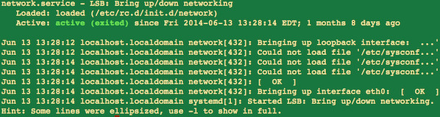Fig.01: CentOS / RHEL 7 Networking Service Status Command

CentOS 7 / RHEL 7 restart network service
sudo systemctl restart network.service
OR
sudo systemctl restart network

CentOS 7 / RHEL 7 start network service
sudo systemctl start network.service
OR
sudo systemctl start network

CentOS 7 / RHEL 7 stop network service
sudo systemctl stop network.service
OR
sudo systemctl stop network
Sample outputs:
Animated gif 01: systemctl command in action

A note about old service and chkconfig command
The service and chkconfig commands are still available in the system and work as expected, but are only included for compatibility reasons and should be avoided as may be dropped in future release.

https://www.servernoobs.com/centos-and-rhel-7-restart-stop-start-networking-commands/

CentOS and RHEL 7 Restart, Stop, Start Networking Commands
admin April 22, 2018 13,997 Views

I recently installed CentOS Linux version 7 or Red Hat Enterprise Linux version 7. How can I restart networking service using command line options? How can I start / stop and restart networking service on a CentOS/RHEL 7 based system?

CentOS 7 / RHEL 7 / Fedora Linux (many other modern distor) uses Systemd. It is a system and service manager for Linux operating systems. In newer distro such as CentOS7/RHEL7 systemd replaces Upstart as the default init system.

In older versions of CentOS or Red Hat Enterprise Linux, you used init scripts located in the /etc/rc.d/init.d/ directory. These init scripts were typically written in Bash, and allowed the system administrator to control the state of services and daemons in their system. In CentOS/RHEL 7, these init scripts have been replaced with service units.
CentOS 7 / RHEL 7 networking service name
To bring up/down networking service you need to use the network.service.

Say hello to systemctl command
Use this command to control the systemd system and act as a service manager.

CentOS 7 / RHEL 7 get status of network service
sudo systemctl status network.service
OR

sudo systemctl status network

CentOS 7 / RHEL 7 restart network service
sudo systemctl restart network.service
OR

sudo systemctl restart network
CentOS 7 / RHEL 7 start network service
sudo systemctl start network.service
OR

sudo systemctl start network
CentOS 7 / RHEL 7 stop network service
sudo systemctl stop network.service
OR

sudo systemctl stop network
A note about old service and chkconfig command
The service and chkconfig commands are still available in the system and work as expected, but are only included for compatibility reasons and should be avoided as may be dropped in future release.

#
# 20191220
#

SD#3409605
https://sd.tcsbank.ru/0/Nui/ViewModule.aspx#SectionModuleV2/CaseSection/CasePage/edit/cd50e7f3-5e8c-4ed1-8a8a-d95a56a18a57

Высвобождение памяти /var/log/journal/ на серверах postgresql

Коллеги, у нас в среднем по 100Мб ОП занято логами журнала системы.
Для изменения необходимо в файле /etc/systemd/journald.conf изменить
#Storage=auto
На
Storage=persistent
И сделать
systemctl restart systemd-journald
Теперь
du -hs /var/log/journal/
25M /var/log/journal/

................................................................................

https://www.freedesktop.org/software/systemd/man/journald.conf.html

Storage=
Controls where to store journal data. One of "volatile", "persistent", "auto" and "none". If "volatile", journal log data will be stored only in memory, i.e. below the /run/log/journal hierarchy (which is created if needed). If "persistent", data will be stored preferably on disk, i.e. below the /var/log/journal hierarchy (which is created if needed), with a fallback to /run/log/journal (which is created if needed), during early boot and if the disk is not writable. "auto" is similar to "persistent" but the directory /var/log/journal is not created if needed, so that its existence controls where log data goes. "none" turns off all storage, all log data received will be dropped. Forwarding to other targets, such as the console, the kernel log buffer, or a syslog socket will still work however. Defaults to "auto".

SystemMaxUse= and RuntimeMaxUse= control how much disk space the journal may use up at most. SystemKeepFree= and RuntimeKeepFree= control how much disk space systemd-journald shall leave free for other uses. systemd-journald will respect both limits and use the smaller of the two values.

................................................................................

list_of_hosts="" ; while read var1_hosts ; do list_of_hosts="${list_of_hosts} ${var1_hosts}" ; done << 'EOF' ; for var1_hosts in ${list_of_hosts} ; do SSHPASS="$(pass common/linux)" sshpass -e timeout 10 ssh -t -oStrictHostKeyChecking=no -oPubkeyAuthentication=no bsv@${var1_hosts}.tcsbank.ru "( echo '$(pass common/linux)' | sudo -S -i sh -c 'echo ; hostname ; puppet --version' )" ; done

................................................................................

[support@centos work]$ for var1_hosts in ds-postgresql0{1..9}p ds-postgresql10p; do SSHPASS="$(pass common/linux)" sshpass -e timeout 10 ssh -t -oStrictHostKeyChecking=no -oPubkeyAuthentication=no bsv@${var1_hosts}.tcsbank.ru "( echo '$(pass common/linux)' | sudo -S -i sh -c 'echo ; hostname ; df -hT /var ')" ; done

................................................................................

[root@ds-postgresql06p ~]# du -sh /run/log/journal/*
744M /run/log/journal/c1595fe9093f497daf6aac5d762fd2a4
[root@ds-postgresql06p ~]# ls -Alh /run/log/journal/*
total 744M
-rwxr-x---+ 1 root systemd-journal 64M Oct 30 20:37 system@509bc6e34fc34233bf2d6563fe79e20d-0000000000413f31-000595e8b823fede.journal
-rwxr-x---+ 1 root systemd-journal 64M Nov 2 19:46 system@509bc6e34fc34233bf2d6563fe79e20d-0000000000422d3c-000596242e2d510c.journal
-rwxr-x---+ 1 root systemd-journal 64M Nov 5 18:49 system@509bc6e34fc34233bf2d6563fe79e20d-0000000000431bb0-0005965fd39e498f.journal
-rwxr-x---+ 1 root systemd-journal 64M Nov 8 17:53 system@509bc6e34fc34233bf2d6563fe79e20d-00000000004409f9-0005969b604826fa.journal
-rwxr-x---+ 1 root systemd-journal 64M Nov 11 17:01 system@509bc6e34fc34233bf2d6563fe79e20d-000000000044f815-000596d6f28cfbcc.journal
-rwxr-x---+ 1 root systemd-journal 64M Nov 14 15:59 system@509bc6e34fc34233bf2d6563fe79e20d-000000000045e69b-000597128fcbfabf.journal
-rwxr-x---+ 1 root systemd-journal 64M Nov 17 15:03 system@509bc6e34fc34233bf2d6563fe79e20d-000000000046d460-0005974e0ef20fdc.journal
-rwxr-x---+ 1 root systemd-journal 64M Nov 20 00:38 system@509bc6e34fc34233bf2d6563fe79e20d-000000000047c2e0-000597899eeb9b73.journal
-rwxr-x---+ 1 root systemd-journal 56M Nov 22 04:18 system@509bc6e34fc34233bf2d6563fe79e20d-0000000000489824-000597b9e0e2bd07.journal
-rwxr-x---+ 1 root systemd-journal 56M Nov 24 07:54 system@509bc6e34fc34233bf2d6563fe79e20d-0000000000495dfb-000597e5320ec146.journal
-rwxr-x---+ 1 root systemd-journal 56M Nov 26 11:34 system@509bc6e34fc34233bf2d6563fe79e20d-00000000004a23fe-000598106f8248c0.journal
-rwxr-x---+ 1 root systemd-journal 56M Nov 28 15:01 system@509bc6e34fc34233bf2d6563fe79e20d-00000000004aea1b-0005983bbde96432.journal
-rwxr-x---+ 1 root systemd-journal 8.0M Nov 28 15:01 system@509bc6e34fc34233bf2d6563fe79e20d-00000000004bb031-00059866e114fa55.journal
[root@ds-postgresql06p ~]# journalctl --vacuum-size=100M
Deleted archived journal /run/log/journal/c1595fe9093f497daf6aac5d762fd2a4/system@509bc6e34fc34233bf2d6563fe79e20d-0000000000413f31-000595e8b823fede.journal (64.0M).
Deleted archived journal /run/log/journal/c1595fe9093f497daf6aac5d762fd2a4/system@509bc6e34fc34233bf2d6563fe79e20d-0000000000422d3c-000596242e2d510c.journal (64.0M).
Deleted archived journal /run/log/journal/c1595fe9093f497daf6aac5d762fd2a4/system@509bc6e34fc34233bf2d6563fe79e20d-0000000000431bb0-0005965fd39e498f.journal (64.0M).
Deleted archived journal /run/log/journal/c1595fe9093f497daf6aac5d762fd2a4/system@509bc6e34fc34233bf2d6563fe79e20d-00000000004409f9-0005969b604826fa.journal (64.0M).
Deleted archived journal /run/log/journal/c1595fe9093f497daf6aac5d762fd2a4/system@509bc6e34fc34233bf2d6563fe79e20d-000000000044f815-000596d6f28cfbcc.journal (64.0M).
Deleted archived journal /run/log/journal/c1595fe9093f497daf6aac5d762fd2a4/system@509bc6e34fc34233bf2d6563fe79e20d-000000000045e69b-000597128fcbfabf.journal (64.0M).
Deleted archived journal /run/log/journal/c1595fe9093f497daf6aac5d762fd2a4/system@509bc6e34fc34233bf2d6563fe79e20d-000000000046d460-0005974e0ef20fdc.journal (64.0M).
Deleted archived journal /run/log/journal/c1595fe9093f497daf6aac5d762fd2a4/system@509bc6e34fc34233bf2d6563fe79e20d-000000000047c2e0-000597899eeb9b73.journal (64.0M).
Deleted archived journal /run/log/journal/c1595fe9093f497daf6aac5d762fd2a4/system@509bc6e34fc34233bf2d6563fe79e20d-0000000000489824-000597b9e0e2bd07.journal (56.0M).
Deleted archived journal /run/log/journal/c1595fe9093f497daf6aac5d762fd2a4/system@509bc6e34fc34233bf2d6563fe79e20d-0000000000495dfb-000597e5320ec146.journal (56.0M).
Deleted archived journal /run/log/journal/c1595fe9093f497daf6aac5d762fd2a4/system@509bc6e34fc34233bf2d6563fe79e20d-00000000004a23fe-000598106f8248c0.journal (56.0M).
Vacuuming done, freed 680.0M of archived journals on disk.
Deleted archived journal /var/log/journal/c1595fe9093f497daf6aac5d762fd2a4/system@95bcf5cd41184dfca4112df3cc7c7350-0000000000000001-000595e8b823fede.journal (128.0M).
Deleted archived journal /var/log/journal/c1595fe9093f497daf6aac5d762fd2a4/system@95bcf5cd41184dfca4112df3cc7c7350-000000000001fdc2-000596683dc92d02.journal (128.0M).
Deleted archived journal /var/log/journal/c1595fe9093f497daf6aac5d762fd2a4/system@95bcf5cd41184dfca4112df3cc7c7350-000000000003fb9e-000596e79d229a5b.journal (128.0M).
Deleted archived journal /var/log/journal/c1595fe9093f497daf6aac5d762fd2a4/system@95bcf5cd41184dfca4112df3cc7c7350-000000000005f989-0005976729bd14b6.journal (128.0M).
Deleted archived journal /var/log/journal/c1595fe9093f497daf6aac5d762fd2a4/system@95bcf5cd41184dfca4112df3cc7c7350-000000000007ec62-000597da1eefdb14.journal (128.0M).
Deleted archived journal /var/log/journal/c1595fe9093f497daf6aac5d762fd2a4/system@00059866e292a4ac-f6a7e9fe14ca9921.journal~ (48.0M).
Deleted archived journal /var/log/journal/c1595fe9093f497daf6aac5d762fd2a4/system@e8aa204fd5e649ccbe0070cbd40de6de-0000000000000001-00059866e292c79b.journal (72.0M).
Deleted archived journal /var/log/journal/c1595fe9093f497daf6aac5d762fd2a4/user-4518@53c0bfb30e724559bc2d41436f48d22d-0000000000004da6-00059877d3530a7f.journal (8.0M).
Deleted archived journal /var/log/journal/c1595fe9093f497daf6aac5d762fd2a4/system@e8aa204fd5e649ccbe0070cbd40de6de-000000000001026b-0005989f53432f20.journal (72.0M).
Deleted archived journal /var/log/journal/c1595fe9093f497daf6aac5d762fd2a4/system@e8aa204fd5e649ccbe0070cbd40de6de-00000000000204fd-000598d7f295a896.journal (72.0M).
Deleted archived journal /var/log/journal/c1595fe9093f497daf6aac5d762fd2a4/system@e8aa204fd5e649ccbe0070cbd40de6de-000000000003086c-0005991075f8c23e.journal (72.0M).
Deleted archived journal /var/log/journal/c1595fe9093f497daf6aac5d762fd2a4/system@e8aa204fd5e649ccbe0070cbd40de6de-0000000000040b40-000599491834e4c3.journal (72.0M).
Deleted archived journal /var/log/journal/c1595fe9093f497daf6aac5d762fd2a4/user-4429@70009b5a87174c749071936baf12eeac-000000000004517f-00059958694109d8.journal (8.0M).
Vacuuming done, freed 1.0G of archived journals on disk.
[root@ds-postgresql06p ~]# ls -Alh /run/log/journal/*
total 64M
-rwxr-x---+ 1 root systemd-journal 56M Nov 28 15:01 system@509bc6e34fc34233bf2d6563fe79e20d-00000000004aea1b-0005983bbde96432.journal
-rwxr-x---+ 1 root systemd-journal 8.0M Nov 28 15:01 system@509bc6e34fc34233bf2d6563fe79e20d-00000000004bb031-00059866e114fa55.journal
[root@ds-postgresql06p ~]# du -sh /run/log/journal/
64M /run/log/journal/
[root@ds-postgresql06p ~]#

................................................................................

[s.belogrud@TCS4357]# cat site/profile/manifests/postgres/journald.pp
class profile::postgres::journald {
class {'journald': options => {
'Storage' => 'persistent',
'SplitMode' => 'uid',
'ForwardToKMsg' => 'no',
'SystemMaxUse' => '100M',
}
}
}
[s.belogrud@TCS4357]#

[root@ds-postgresql06p ~]# vim /etc/systemd/journald.conf

[root@ds-postgresql06p ~]# grep -ie "SystemMaxUse" /etc/systemd/journald.conf
#SystemMaxUse=
SystemMaxUse=100M
[root@ds-postgresql06p ~]#

[root@ds-postgresql06p ~]#
[root@ds-postgresql06p ~]# systemctl status systemd-journald
? systemd-journald.service - Journal Service
Loaded: loaded (/usr/lib/systemd/system/systemd-journald.service; static; vendor preset: disabled)
Active: active (running) since Wed 2019-12-18 12:36:20 MSK; 8s ago
Docs: man:systemd-journald.service(8)
man:journald.conf(5)
Main PID: 27517 (systemd-journal)
Status: "Processing requests..."
CGroup: /system.slice/systemd-journald.service
L-27517 /usr/lib/systemd/systemd-journald

Dec 18 12:36:20 ds-postgresql06p.tcsbank.ru systemd-journal[27517]: Permanent journal is using 176.0M (max allowed 100.0M, trying to leave 2.9G free of 14.2G available > current limit 176.0M).
Dec 18 12:36:20 ds-postgresql06p.tcsbank.ru systemd-journal[27517]: Journal started
[root@ds-postgresql06p ~]# df -hT /run
Filesystem Type Size Used Avail Use% Mounted on
tmpfs tmpfs 7.8G 65M 7.7G 1% /run
[root@ds-postgresql06p ~]#

................................................................................

[root@ds-postgresql06p ~]# vim /etc/systemd/journald.conf
[root@ds-postgresql06p ~]# puppet agent -t --noop --environment 20191218_SD3409605
Info: Using configured environment '20191218_SD3409605'
Info: Retrieving pluginfacts
Info: Retrieving plugin
Info: Loading facts
Info: Applying configuration version 'vm-puppetmaster02p.tcsbank.ru-20191218_SD3409605-83eb9a14e88'
Notice: /Stage[main]/Journald::Config/Ini_setting[/etc/systemd/journald.conf [Journal] SystemMaxUse]/ensure: current_value 'absent', should be 'present' (noop) (corrective)
Info: /Stage[main]/Journald::Config/Ini_setting[/etc/systemd/journald.conf [Journal] SystemMaxUse]: Scheduling refresh of Service[systemd-journald]
Notice: Class[Journald::Config]: Would have triggered 'refresh' from 1 event
Info: Class[Journald::Config]: Scheduling refresh of Class[Journald::Service]
Notice: Class[Journald::Service]: Would have triggered 'refresh' from 1 event
Info: Class[Journald::Service]: Scheduling refresh of Service[systemd-journald]
Notice: /Stage[main]/Journald::Service/Service[systemd-journald]: Would have triggered 'refresh' from 2 events
Notice: Class[Journald::Service]: Would have triggered 'refresh' from 1 event
Notice: Class[Journald]: Would have triggered 'refresh' from 2 events
Notice: Stage[main]: Would have triggered 'refresh' from 3 events
Notice: Applied catalog in 3.68 seconds
[root@ds-postgresql06p ~]#

................................................................................

[support@centos work]$ for var1_hosts in m1-postgresql0{1..9}p m1-postgresql{10..330}p; do SSHPASS="$(pass common/linux)" sshpass -e timeout 60 ssh -t -oStrictHostKeyChecking=no -oPubkeyAuthentication=no bsv@${var1_hosts}.tcsbank.ru "( echo '$(pass common/linux)' | sudo -S -i sh -c 'echo ; echo ; hostname ; grep -ie "SystemMaxUse" /etc/systemd/journald.conf ; du -sh /run/log/ ; journalctl --vacuum-size=100M ; du -sh /run/log/ ; ')" ; done | tee -a /tmp/$(date +%Y%m%d-%H%M).postgresql.ssh.log.txt

[support@centos work]$ for var1_hosts in ds-postgresql0{1..9}p ds-postgresql{10..330}p; do SSHPASS="$(pass common/linux)" sshpass -e timeout 60 ssh -t -oStrictHostKeyChecking=no -oPubkeyAuthentication=no bsv@${var1_hosts}.tcsbank.ru "( echo '$(pass common/linux)' | sudo -S -i sh -c 'echo ; echo ; hostname ; df -hT /run ; puppet agent -t ; ')" ; done | tee -a /tmp/$(date +%Y%m%d-%H%M).postgresql.ssh.log.txt

................................................................................
................................................................................
#
# 20191219
#

[root@m1-postgresql08p ~]# du -sh /run/systemd/*
0 /run/systemd/ask-password
0 /run/systemd/ask-password-block
0 /run/systemd/cgroups-agent
28K /run/systemd/generator
12K /run/systemd/generator.late
0 /run/systemd/inaccessible
0 /run/systemd/initctl
4.0K /run/systemd/journal
0 /run/systemd/machines
0 /run/systemd/netif
0 /run/systemd/notify
0 /run/systemd/private
4.0K /run/systemd/seats
692M /run/systemd/sessions
0 /run/systemd/shutdown
0 /run/systemd/shutdownd
428K /run/systemd/system
3.7M /run/systemd/users
[root@m1-postgresql08p ~]# vim /etc/systemd/journald.conf
[root@m1-postgresql08p ~]# journalctl --vacuum-size=100M
Vacuuming done, freed 0B of archived journals on disk.
[root@m1-postgresql08p ~]#

#
# If only update - it doesn't help to free space and remove logs.

[root@m1-postgresql08p ~]# yum update systemd

[root@m1-postgresql08p ~]# du -sh /run/systemd/sessions
693M /run/systemd/sessions
[root@m1-postgresql08p ~]#

[root@m1-postgresql08p ~]# find /run/systemd/sessions/ -type f -mtime -1 | head
/run/systemd/sessions/402757
/run/systemd/sessions/402756
/run/systemd/sessions/402754
/run/systemd/sessions/402755
/run/systemd/sessions/402753
/run/systemd/sessions/402735
/run/systemd/sessions/402752
/run/systemd/sessions/402750
/run/systemd/sessions/402751
/run/systemd/sessions/402749
[root@m1-postgresql08p ~]# ls -Alh /run/systemd/sessions/402757
-rw-r--r--. 1 root root 255 Dec 19 12:26 /run/systemd/sessions/402757
[root@m1-postgresql08p ~]# :> /run/systemd/sessions/402757
[root@m1-postgresql08p ~]# ls -Alh /run/systemd/sessions/402757
-rw-r--r--. 1 root root 0 Dec 19 12:26 /run/systemd/sessions/402757
[root@m1-postgresql08p ~]# find /run/systemd/sessions/ -type f -mtime -1 | xargs :>
-bash: syntax error near unexpected token `newline'
[root@m1-postgresql08p ~]# for var1 in $(find /run/systemd/sessions/ -type f -mtime -1) ; do :> $var1 ; done
[root@m1-postgresql08p ~]# du -sh /run/systemd/sessions
681M /run/systemd/sessions
[root@m1-postgresql08p ~]# ls -Alh /run/systemd/sessions/402757
-rw-r--r--. 1 root root 0 Dec 19 12:28 /run/systemd/sessions/402757
[root@m1-postgresql08p ~]#

[root@m1-postgresql08p ~]# find /run/systemd/sessions/ -type f -mtime -1 -exec rm -f {} \;
[root@m1-postgresql08p ~]# du -sh /run/systemd/sessions/
681M /run/systemd/sessions/
[root@m1-postgresql08p ~]# ls -l /run/systemd/sessions/ | wc -l
174235
[root@m1-postgresql08p ~]#

https://unix.stackexchange.com/questions/139513/how-to-clear-journalctl

#
# 20210611
# Useful command to get some info with journalctl.
# I use it here 20210602 Task - tune journald on postgresql servers to free RAM memory
#
https://wiki.archlinux.org/title/Systemd/Journal

Filtering output
journalctl allows for the filtering of the output by specific fields. If there are many messages to display or filtering of large time span has to be done, the output of this command can be extensively delayed.
Examples:
- Show all messages from this boot:
# journalctl -b
However, often one is interested in messages not from the current, but from the previous boot (e.g. if an unrecoverable system crash happened). This is possible through optional offset parameter of the -b flag: journalctl -b -0 shows messages from the current boot, journalctl -b -1 from the previous boot, journalctl -b -2 from the second previous and so on – you can see the list of boots with their numbers by using journalctl --list-boots. See journalctl(1) for a full description; the semantics are more powerful than indicated here.
- Include explanations of log messages from the message catalog where available:
# journalctl -x
Note that this feature should not be used when attaching logs to bug reports and support threads, as to limit extraneous output. You can list all known catalog entries by running journalctl --list-catalog.
- Show all messages from date (and optional time):
# journalctl --since="2012-10-30 18:17:16"
- Show all messages since 20 minutes ago:
# journalctl --since "20 min ago"
- Follow new messages:
# journalctl -f
- Show all messages by a specific executable:
# journalctl /usr/lib/systemd/systemd
- Show all messages by a specific process:
# journalctl _PID=1
- Show all messages by a specific unit:
# journalctl -u man-db.service
- Show all messages from user services by a specific unit:
$ journalctl --user -u dbus
- Show kernel ring buffer:
# journalctl -k
- Show only error, critical and alert priority messages:
# journalctl -p err..alert
You can use numeric log level too, like journalctl -p 3..1. If single number/log level is used, journalctl -p 3, then all higher priority log levels are also included (i.e. 0 to 3 in this case).
- Show auth.log equivalent by filtering on syslog facility:
# journalctl SYSLOG_FACILITY=10
- If the journal directory (by default located under /var/log/journal) contains a large amount of log data then journalctl can take several minutes to filter output. It can be sped up significantly by using --file option to force journalctl to look only into most recent journal:
# journalctl --file /var/log/journal/*/system.journal -f
See journalctl(1), systemd.journal-fields(7), or Lennart Poettering's blog post for details.
Tip: By default, journalctl truncates lines longer than screen width, but in some cases, it may be better to enable wrapping instead of truncating. This can be controlled by the SYSTEMD_LESS environment variable, which contains options passed to less (the default pager) and defaults to FRSXMK (see less(1) and journalctl(1) for details).
By omitting the S option, the output will be wrapped instead of truncated. For example, start journalctl as follows:
$ SYSTEMD_LESS=FRXMK journalctl

To set this behaviour as default, export the variable from ~/.bashrc or ~/.zshrc.
Tip: While the journal is stored in a binary format, the content of stored messages is not modified. This means it is viewable with strings, for example for recovery in an environment which does not have systemd installed, e.g.:
$ strings /mnt/arch/var/log/journal/af4967d77fba44c6b093d0e9862f6ddd/system.journal | grep -i message

#
# Common description about systemd.
https://wiki.archlinux.org/title/Systemd#Systemd_Journal
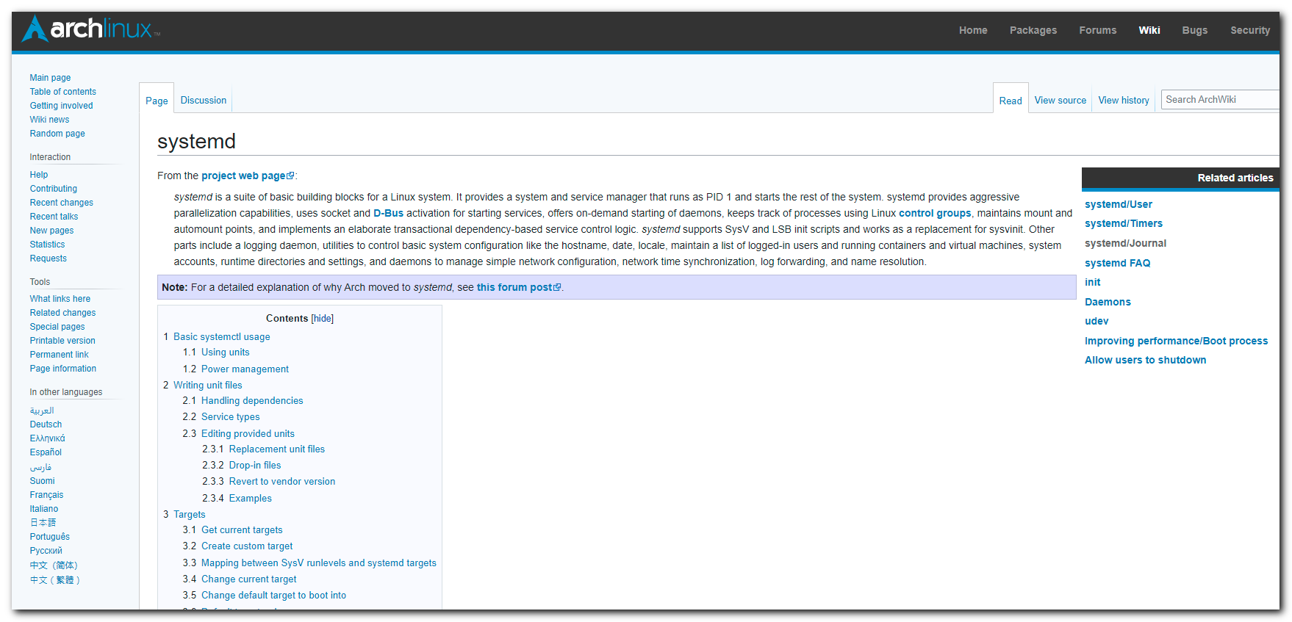
...

Using units
Units can be, for example, services (.service), mount points (.mount), devices (.device) or sockets (.socket).
When using systemctl, you generally have to specify the complete name of the unit file, including its suffix, for example sshd.socket. There are however a few short forms when specifying the unit in the following systemctl commands:
- If you do not specify the suffix, systemctl will assume .service. For example, netctl and netctl.service are equivalent.
- Mount points will automatically be translated into the appropriate .mount unit. For example, specifying /home is equivalent to home.mount.
- Similar to mount points, devices are automatically translated into the appropriate .device unit, therefore specifying /dev/sda2 is equivalent to dev-sda2.device.
See systemd.unit(5) for details.
Note: Some unit names contain an @ sign (e.g. name@string.service): this means that they are instances of a template unit, whose actual file name does not contain the string part (e.g. name@.service). string is called the instance identifier, and is similar to an argument that is passed to the template unit when called with the systemctl command: in the unit file it will substitute the %i specifier. To be more accurate, before trying to instantiate the name@.suffix template unit, systemd will actually look for a unit with the exact name@string.suffix file name, although by convention such a "clash" happens rarely, i.e. most unit files containing an @ sign are meant to be templates. Also, if a template unit is called without an instance identifier, it will just fail, since the %i specifier cannot be substituted.
Tip:
- Most of the following commands also work if multiple units are specified, see systemctl(1) for more information.
- The --now switch can be used in conjunction with enable, disable, and mask to respectively start, stop, or mask the unit immediately rather than after rebooting.
- A package may offer units for different purposes. If you just installed a package, pacman -Qql package | grep -Fe .service -e .socket can be used to check and find them.
Action | Command | Note
Analyzing the system state
Show system status | $ systemctl status
List running units | $ systemctl or  $ systemctl list-units
List failed units | $ systemctl --failed
List installed unit files¹ | $ systemctl list-unit-files
Show process status for a PID | $ systemctl status pid | cgroup slice, memory and parent
Checking the unit status
Show a manual page associated with a unit | $ systemctl help unit | as supported by the unit
Status of a unit | $ systemctl status unit | including whether it is running or not
Check whether a unit is enabled | $ systemctl is-enabled unit
Starting, restarting, reloading a unit
Start a unit immediately | # systemctl start unit
Stop a unit immediately | # systemctl stop unit
Restart a unit | # systemctl restart unit
Reload a unit and its configuration | # systemctl reload unit
Reload systemd manager configuration² | # systemctl daemon-reload | scan for new or changed units
Enabling a unit
Enable a unit to start automatically at boot | # systemctl enable unit
Enable a unit to start automatically at boot and start it immediately | # systemctl enable --now unit
Disable a unit to no longer start at boot | # systemctl disable unit
Reenable a unit³ | # systemctl reenable unit | i.e. disable and enable anew
Masking a unit
Mask a unit to make it impossible to start⁴ | # systemctl mask unit
Unmask a unit | # systemctl unmask unit
- See systemd.unit(5) § UNIT FILE LOAD PATH for the directories where available unit files can be found.
- This does not ask the changed units to reload their own configurations (see the Reload action).
- For example, in case its [Install] section has changed since last enabling it.
- Both manually and as a dependency, which makes masking dangerous.

Power management
polkit is necessary for power management as an unprivileged user. If you are in a local systemd-logind user session and no other session is active, the following commands will work without root privileges. If not (for example, because another user is logged into a tty), systemd will automatically ask you for the root password.
Action | Command
Shut down and reboot the system | $ systemctl reboot
Shut down and power-off the system | $ systemctl poweroff
Suspend the system | $ systemctl suspend
Put the system into hibernation | $ systemctl hibernate
Put the system into hybrid-sleep state (or suspend-to-both) | $ systemctl hybrid-sleep

Writing unit files
The syntax of systemd's unit files (systemd.unit(5)) is inspired by XDG Desktop Entry Specification .desktop files, which are in turn inspired by Microsoft Windows .ini files. Unit files are loaded from multiple locations (to see the full list, run systemctl show --property=UnitPath), but the main ones are (listed from lowest to highest precedence):
- /usr/lib/systemd/system/: units provided by installed packages
- /etc/systemd/system/: units installed by the system administrator
Note:
- The load paths are completely different when running systemd in user mode.
- systemd unit names may only contain ASCII alphanumeric characters, underscores and periods. All other characters must be replaced by C-style "\x2d" escapes, or employ their predefined semantics ('@', '-'). See systemd.unit(5) and systemd-escape(1) for more information.
Look at the units installed by your packages for examples, as well as systemd.service(5) § EXAMPLES.
Tip: Comments prepended with # may be used in unit-files as well, but only in new lines. Do not use end-line comments after systemd parameters or the unit will fail to activate.

Handling dependencies
With systemd, dependencies can be resolved by designing the unit files correctly. The most typical case is that the unit A requires the unit B to be running before A is started. In that case add Requires=B and After=B to the [Unit] section of A. If the dependency is optional, add Wants=B and After=B instead. Note that Wants= and Requires= do not imply After=, meaning that if After= is not specified, the two units will be started in parallel.
Dependencies are typically placed on services and not on #Targets. For example, network.target is pulled in by whatever service configures your network interfaces, therefore ordering your custom unit after it is sufficient since network.target is started anyway.

Service types
There are several different start-up types to consider when writing a custom service file. This is set with the Type= parameter in the [Service] section:
- Type=simple (default): systemd considers the service to be started up immediately. The process must not fork. Do not use this type if other services need to be ordered on this service, unless it is socket activated.
- Type=forking: systemd considers the service started up once the process forks and the parent has exited. For classic daemons use this type unless you know that it is not necessary. You should specify PIDFile= as well so systemd can keep track of the main process.
- Type=oneshot: this is useful for scripts that do a single job and then exit. You may want to set RemainAfterExit=yes as well so that systemd still considers the service as active after the process has exited.
- Type=notify: identical to Type=simple, but with the stipulation that the daemon will send a signal to systemd when it is ready. The reference implementation for this notification is provided by libsystemd-daemon.so.
- Type=dbus: the service is considered ready when the specified BusName appears on DBus's system bus.
- Type=idle: systemd will delay execution of the service binary until all jobs are dispatched. Other than that behavior is very similar to Type=simple.
See the systemd.service(5) § OPTIONS man page for a more detailed explanation of the Type values.

...

2024-11-06 Это из видео с курса Otus. Курс по linux, занятие про systemd.

systemd-analyze time
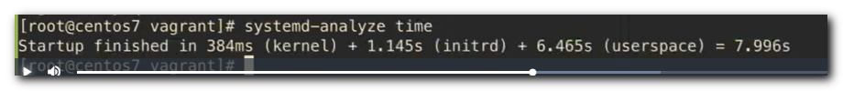

# Show boot timing process.
systemd-analyze blame
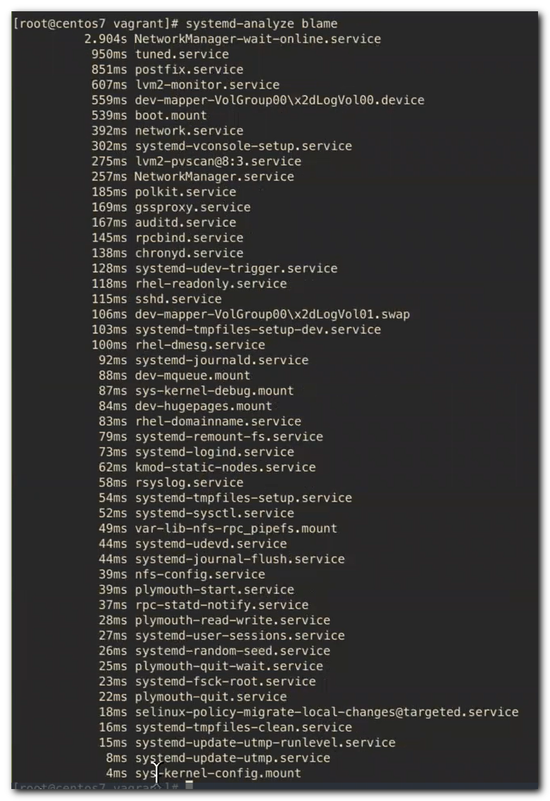

# This trick allows you to see the file without printing the full path like /usr/lib/systemd/system/....
systemctl cat sys-kernel-config.mount
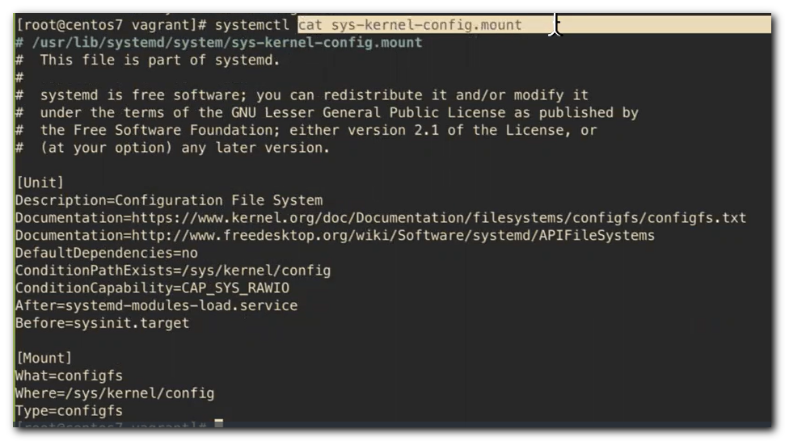

# Каталог со слайсами (срезами). Здесь находятся сервисы и группы сервисов, запущенные в данном контексте.
cd /sys/fs/cgroup/systemd/system.slice
# Например можно параметры посмотреть его cgoup пареметры.
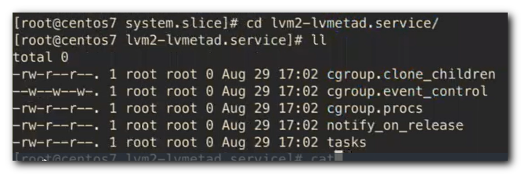

В файлике /etc/systemd/system.conf находятся параметры общие для всех сервисов systemd.
Можно этот файлик скопировать в какой-либо конкретный сервис и раскомментировать нужный параметр, который будет применяться именно для этого сервиса.

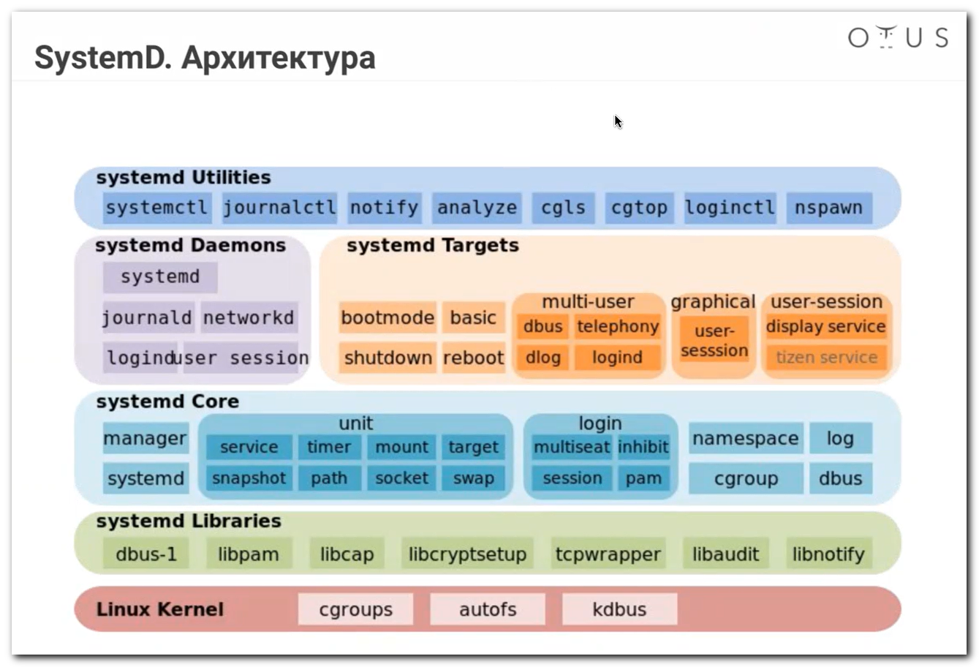

Для обратной совместимости сделана фишка. Если в /etc/init.d написать какой-нибудь скрипт.
echo -e "#!/bin/bash\n echo \"Hello world!\"" > /etc/init.d/test.sh
chmod +x /etc/init.d/test.sh

systemctl status test.sh
systemctl daemon-reload

# К сожалению на wsl такая фишка не проходит. Поэтому без пруфа.
root@work1:~# systemctl status test.sh
System has not been booted with systemd as init system (PID 1). Can't operate.
Failed to connect to bus: Host is down
root@work1:~#
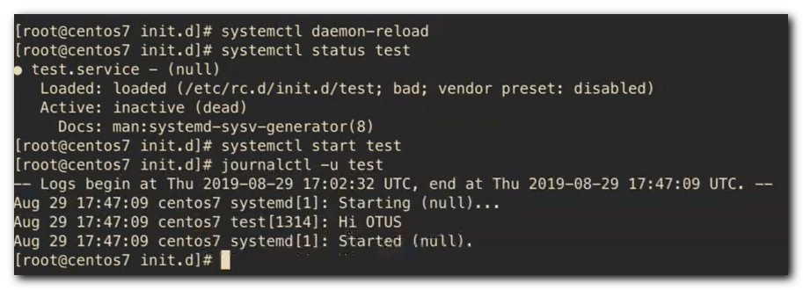
Есть командочка заруливающая часовым поясом.
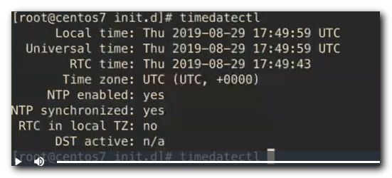
Причём с автодополнением зоны по нажатию табуляции.

2024-11-06
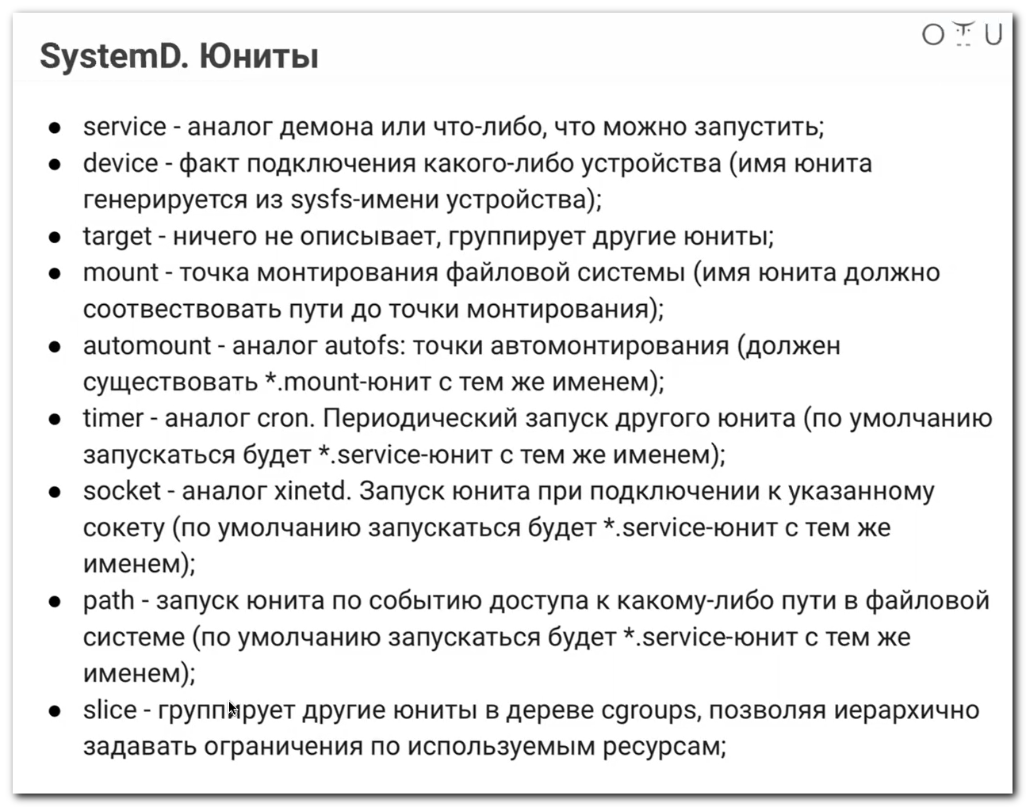
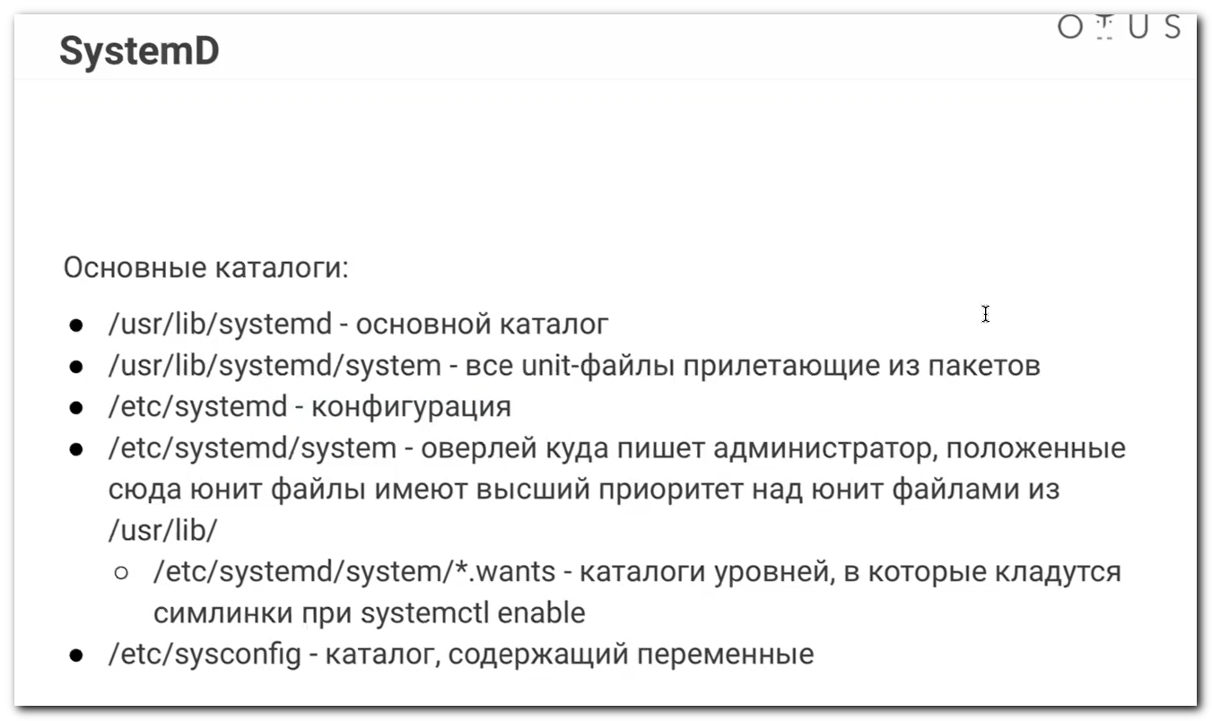
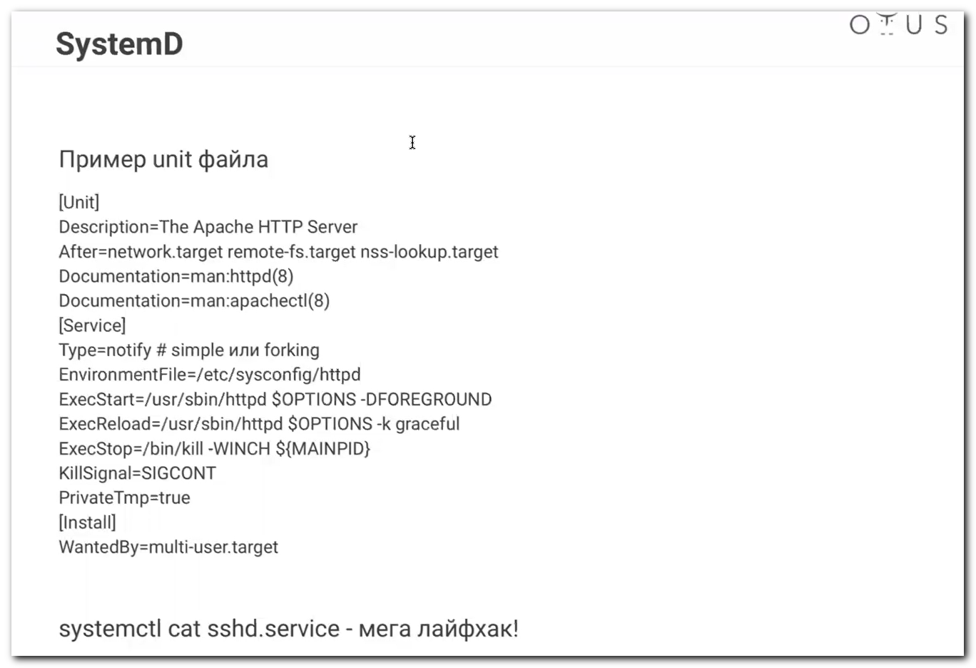
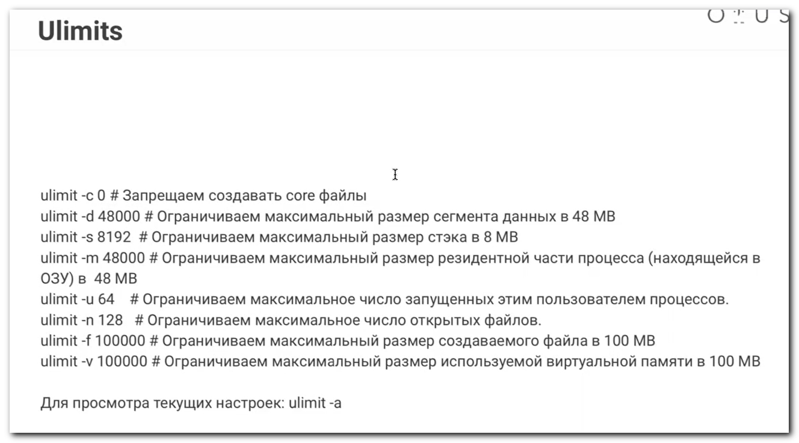
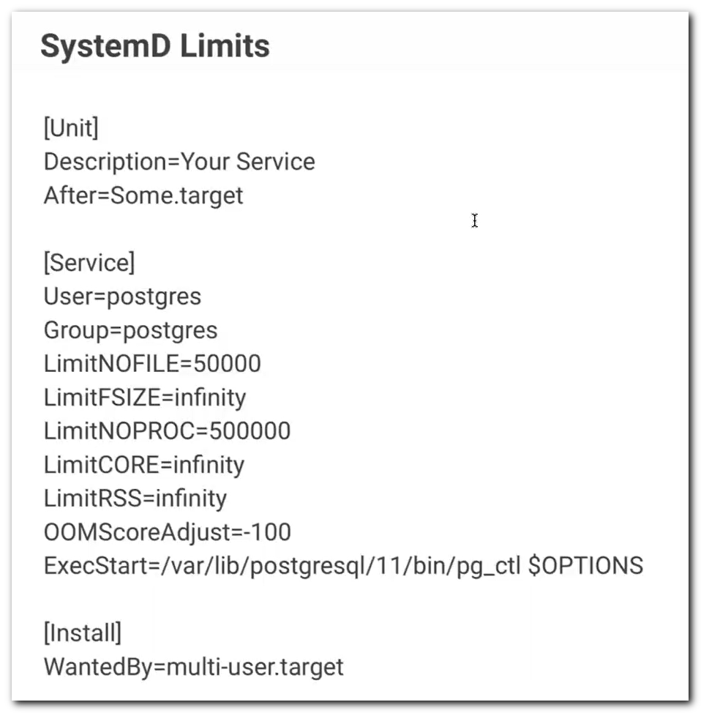
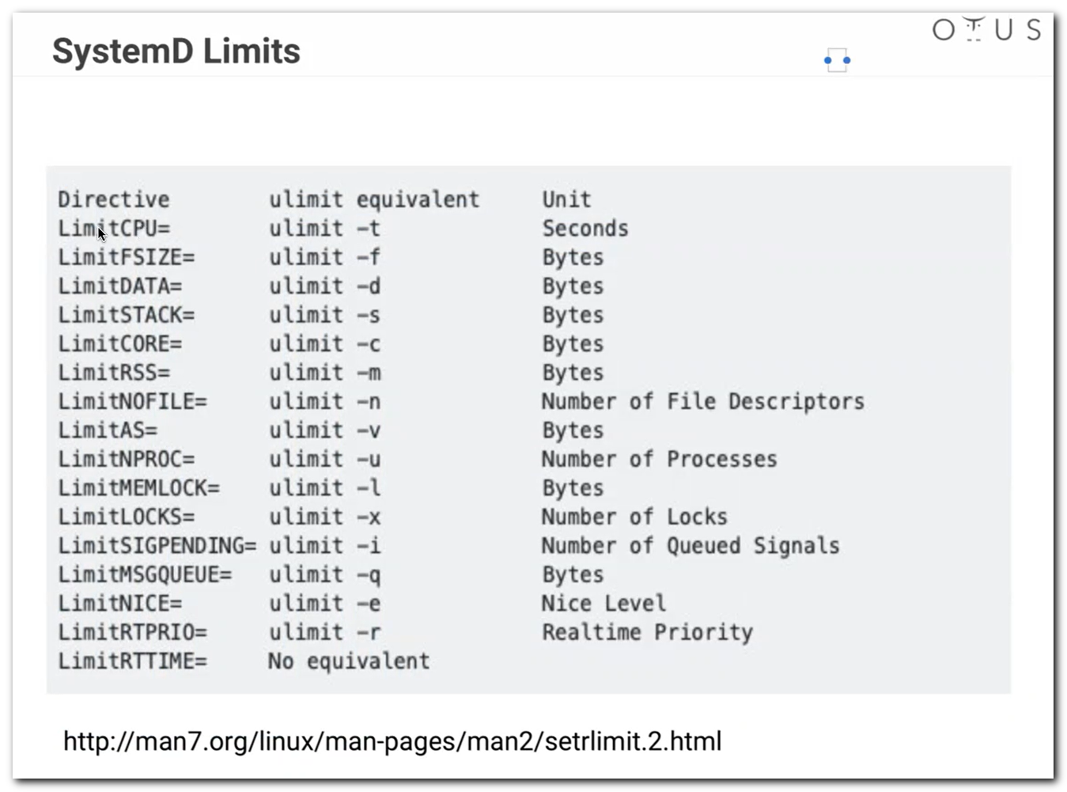
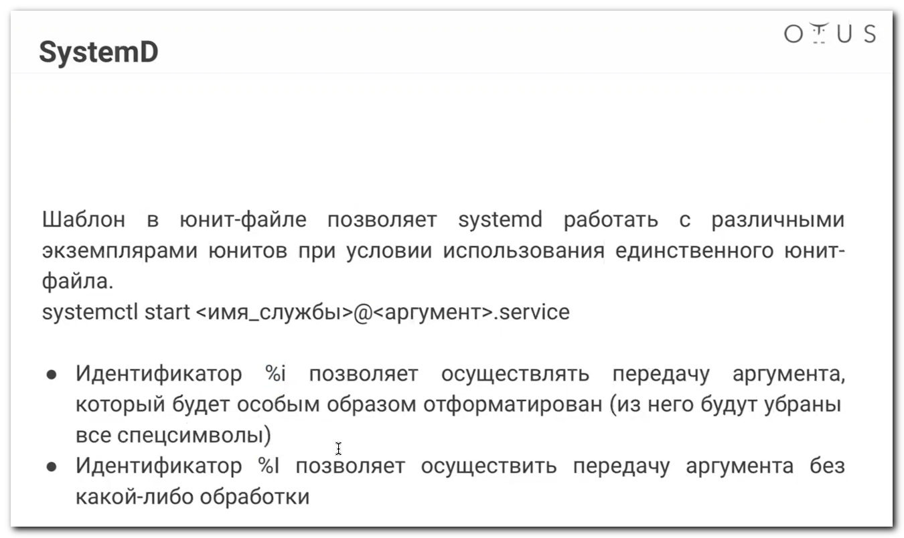
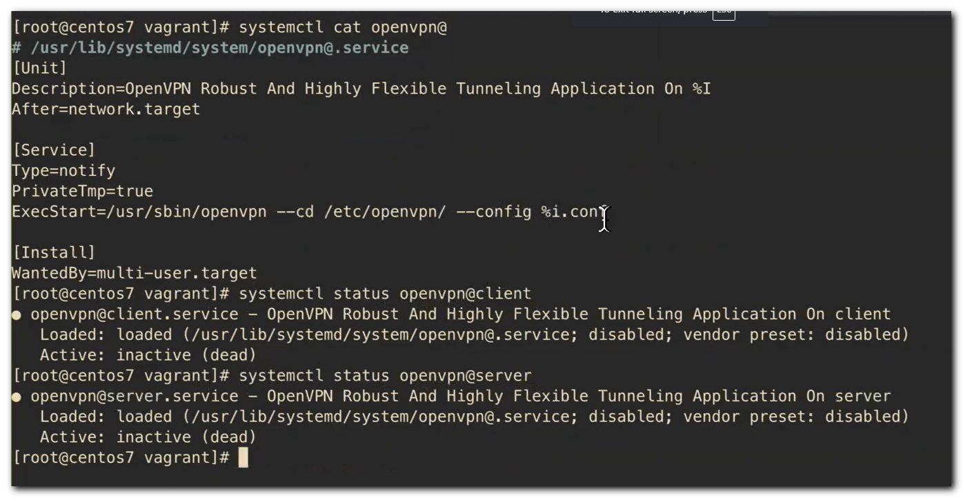
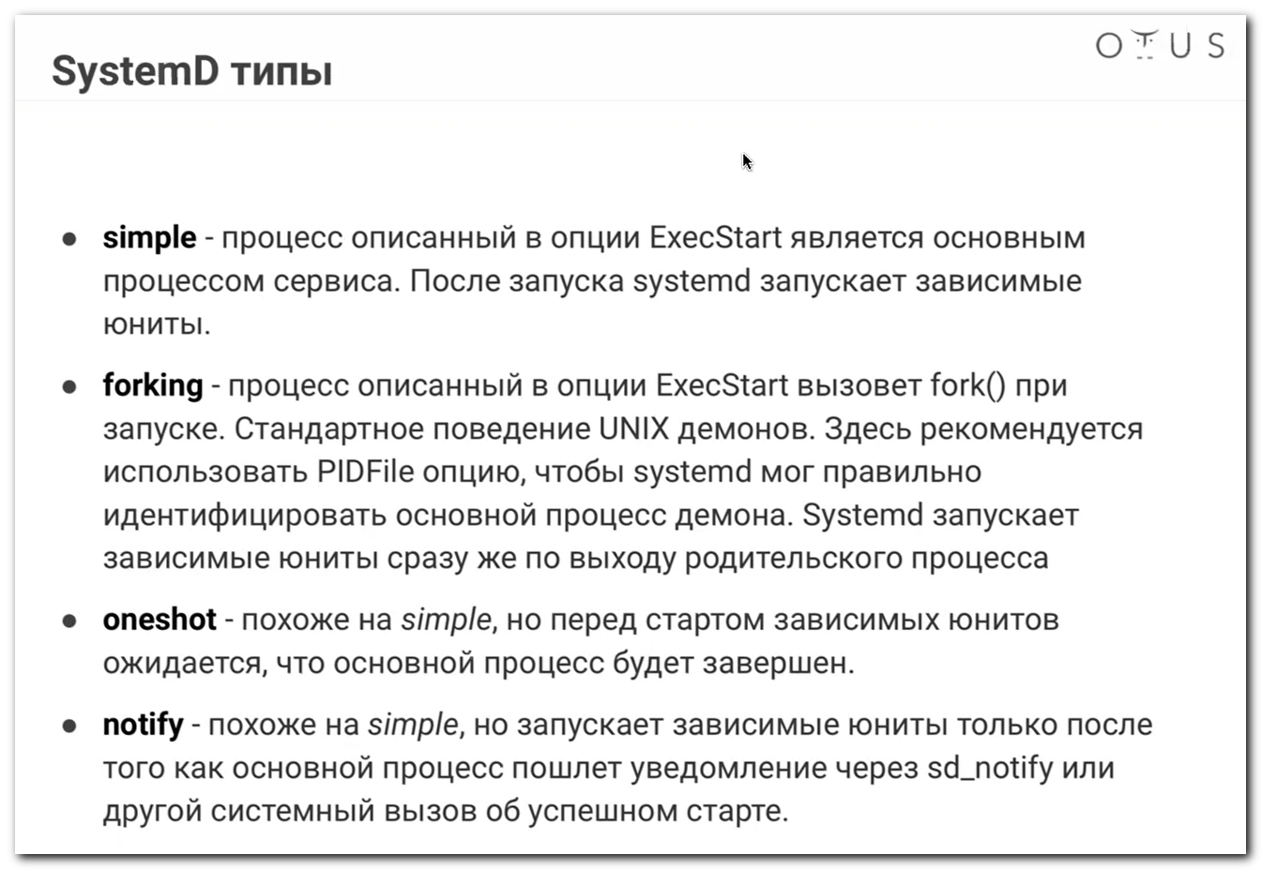
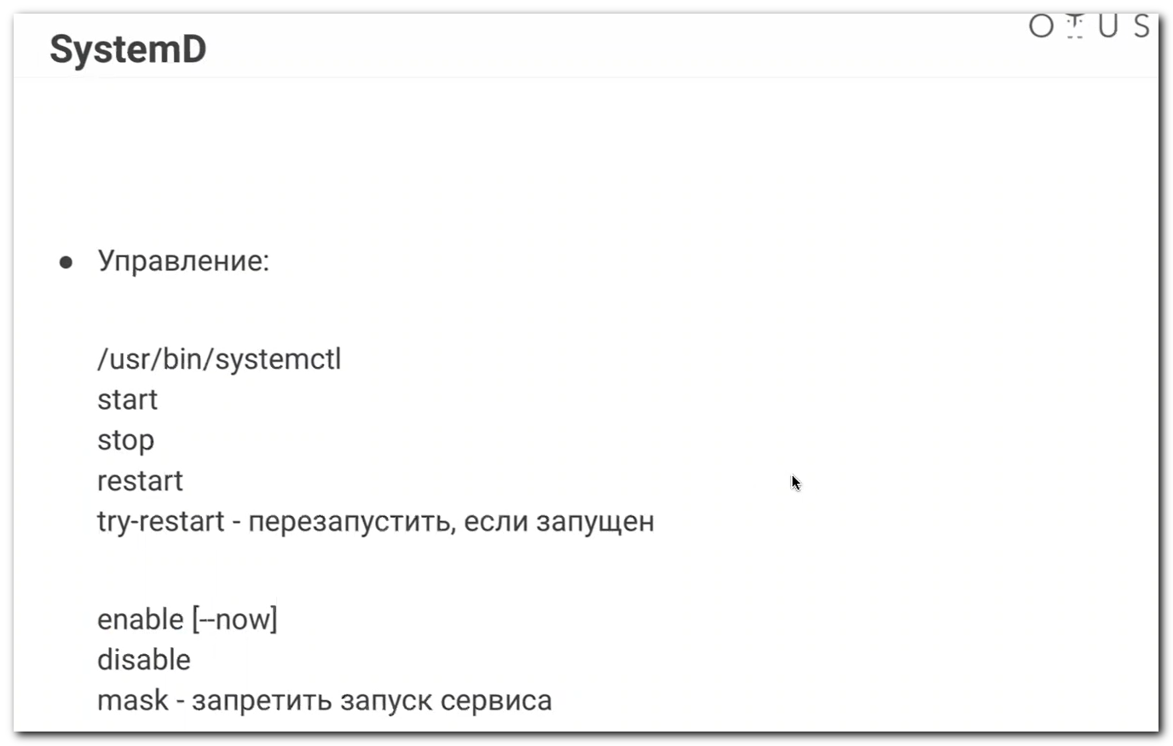
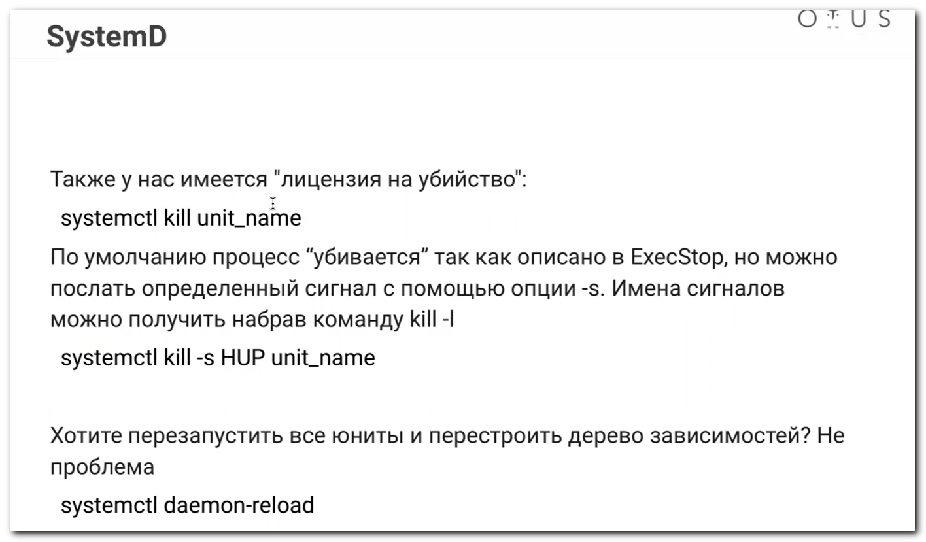
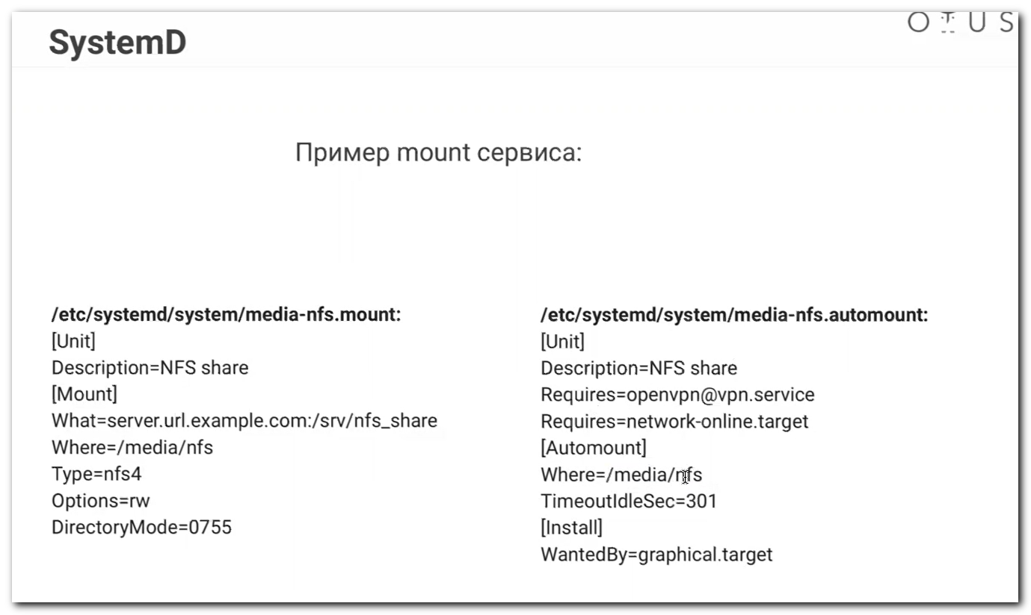
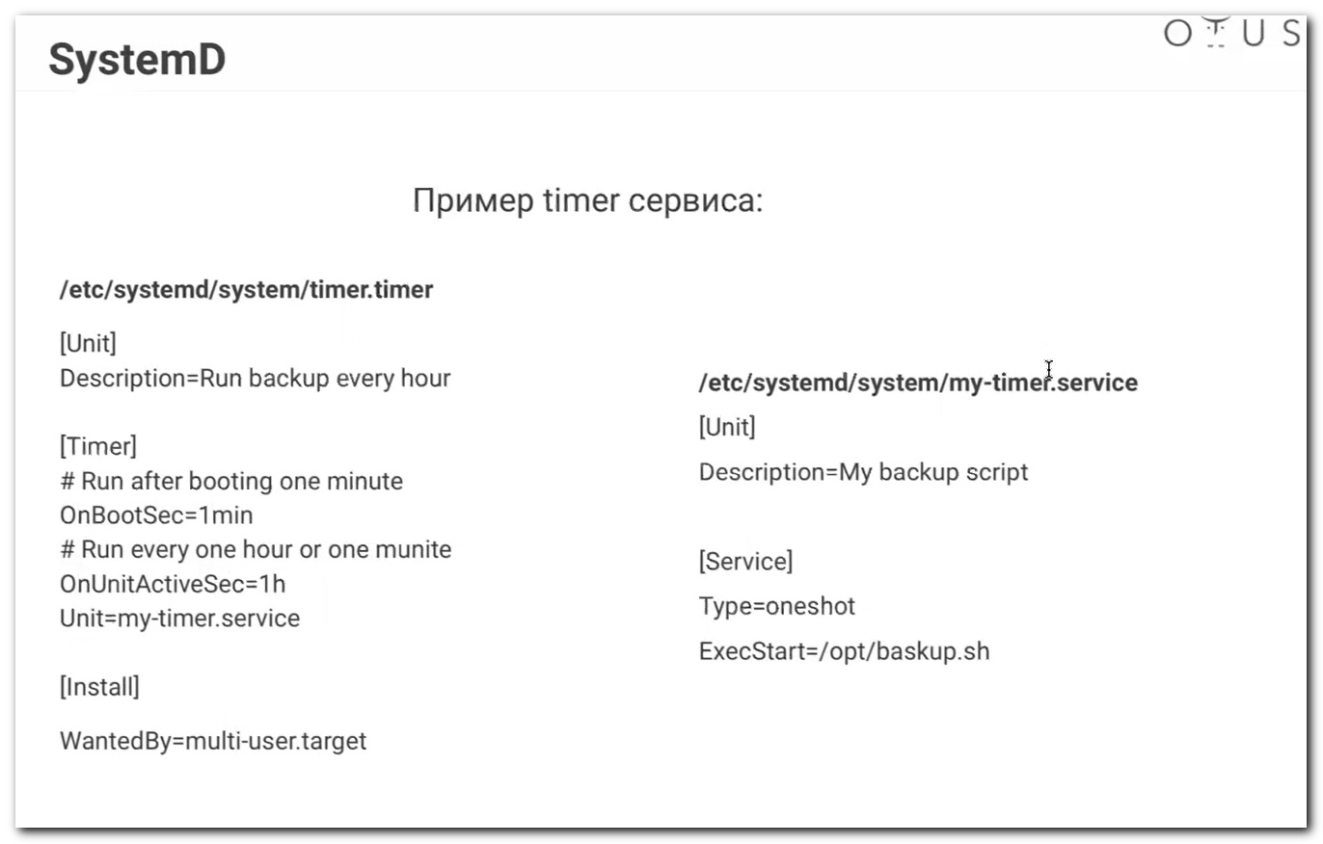
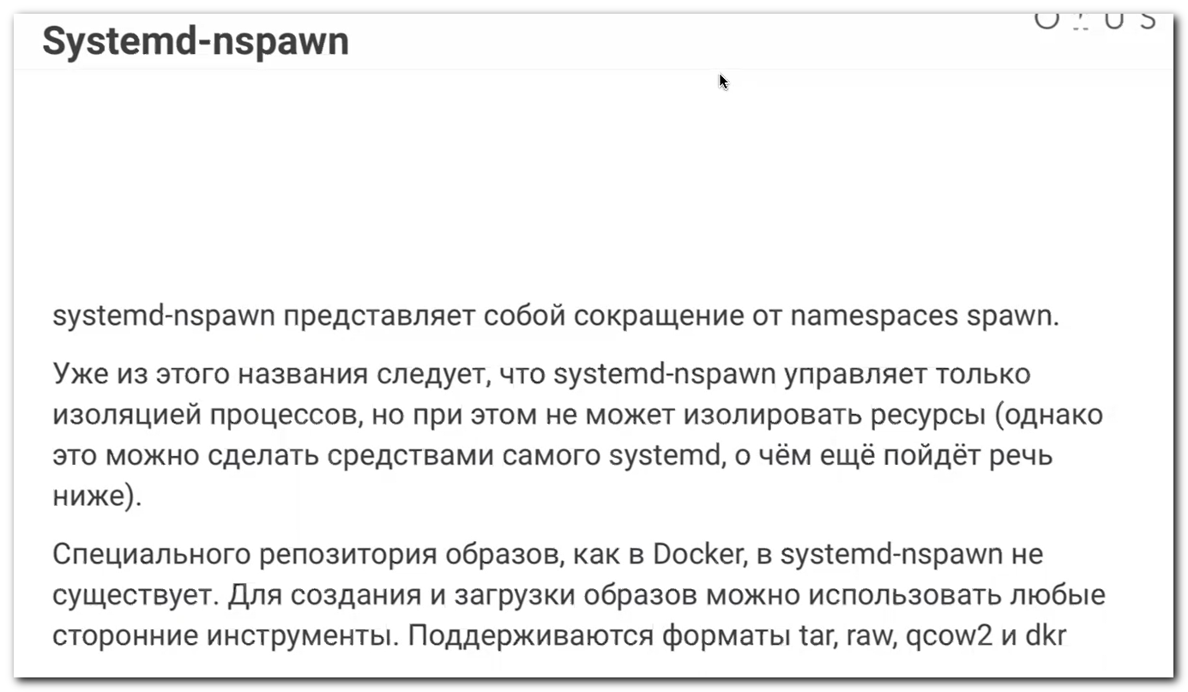
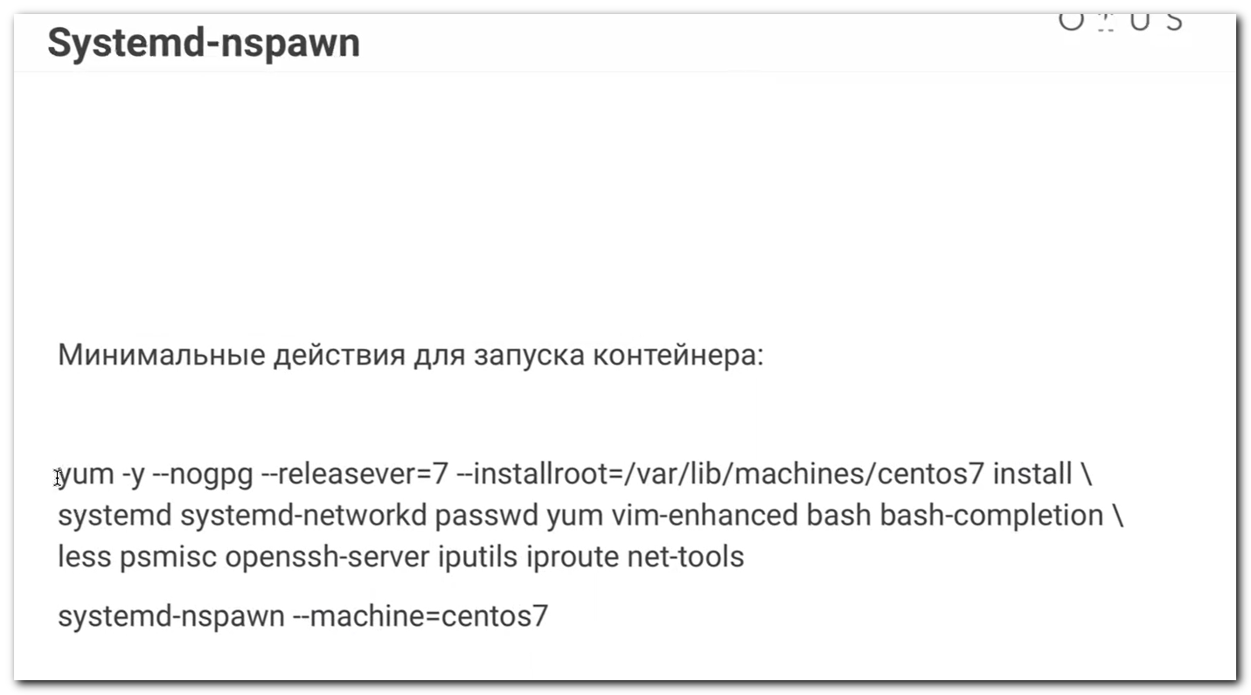
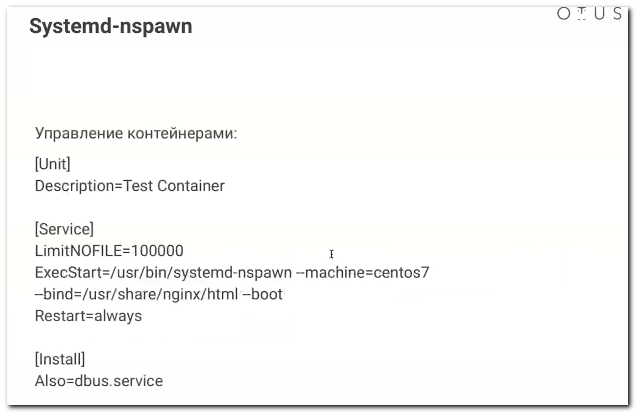
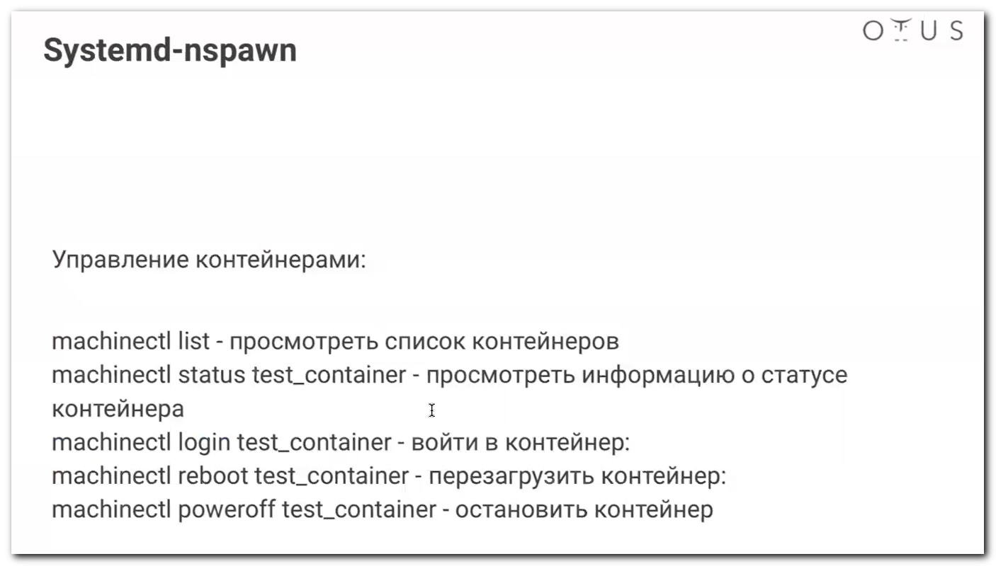

Systemd для администраторов.pdf

